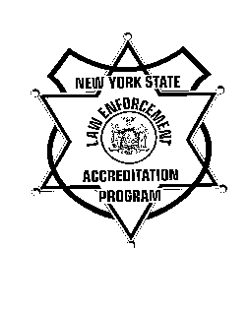 New York State Law Enforcement Accreditation Program

ACCREDITATION ASSESSMENT AGREEMENT

Please Select: Initial or Reaccreditation

On behalf of the (name of agency), I hereby request an on-site assessment pursuant to the requirements set forth by the New York State Law Enforcement Accreditation Council. In making this request, I formally certify that:

(1) The policies and procedures needed to meet all program standards have been fully implemented and in effect for a minimum of three months.

(2) All revisions in our agency's Policy and Procedure Manual have been distributed to appropriate personnel and an orientation of all personnel to the new procedures has been completed.

(3) All forms or logs referred to in our agency's Policy and Procedure Manual are available for review by the assessors and have been in use for a minimum of three months.

(4) There is a separate folder available for review for each of the program standards. Each folder contains at a minimum:

a. A copy of the relevant page from the Standards and Compliance Verification Manual. This page reprints the individual standard and contains a list of suggested strategies which agencies can use to demonstrate compliance;

b. An original Standard Compliance Report with NCR copy attached that identifies the specific ways (documentation, interviews, etc.) in which the agency can show that it has met the intent of the standard;

c. A copy of all departmental policies and procedures that address the standard in question: and

d. Supporting documentation (sample forms, job announcements, lesson plans, etc.) which clearly demonstrates that all components of the standard have been fully implemented.

(5) The agency has done a comprehensive internal review.

Furthermore, I agree to be present and available to assess potential problems throughout the entire period of the on-site assessment. Key personnel are identified by name below and will also be present and available during the entire period of the on-site assessment to answer any questions that the assessors may have.

Program Manager:

Training Officer:

Union Representative:

Records Clerk:

Property Officer:

Evidence Technician:

Personnel Officer:

Fiscal Officer:

(Assessors may want to interview other department personnel as well, but those listed above must be available).

Additionally, I have made the necessary arrangements to ensure the assessment team will have adequate work space and access to a telephone.

Should some unforeseen event occur that impacts this agreement in any way, I will contact the Office of Public Safety, Accreditation Program at once and request that the assessment be postponed until the agency is again in full compliance.

Signature of Chief Executive Officer

Date

